Jasmine – Academic Example
Screening Data

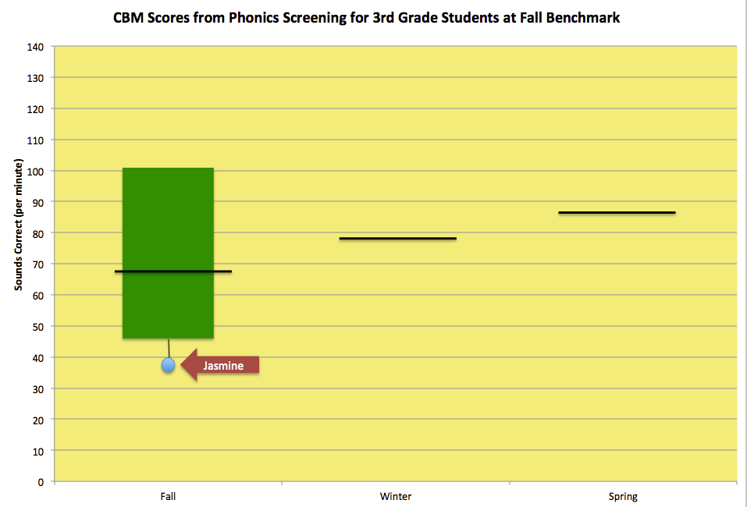
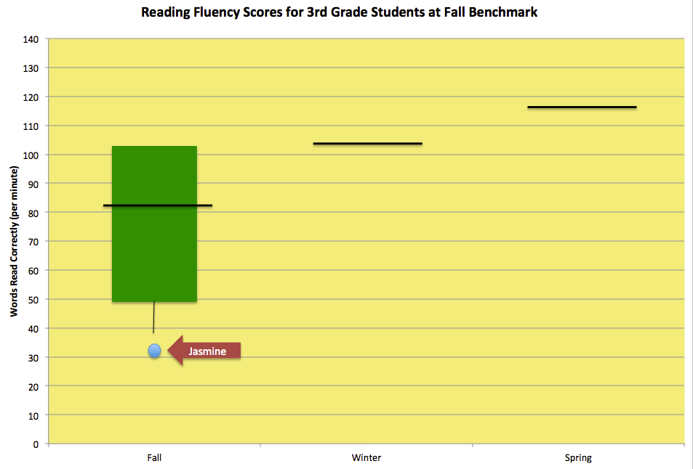

Jasmine’s Oral Reading Fluency Probes from Fall Benchmark

